SIMATS ENGINEERING
ASSESSMENT TOOL 1

COURSE NAME: Computer Networks COURSE CODE: CSA0703
Name: T. Venkata Reddy
Reg no : 192412567

COURSE OUTCOME COVERED

CO1: Apply the functions of OSI layer in enabling reliable data transmission across networks. (BL2, BL3)
Assessment Tool Weightage: 40%

Description about the assessment tool:

Short-answer questions effectively measure conceptual understanding, logical reasoning, and the ability to apply theoretical knowledge without requiring lengthy descriptive responses. This assessment method is also efficient for evaluating multiple OSI-related concepts within a limited time while ensuring objective and consistent evaluation.

Short Answer Test

1. A company needs to transfer a 150 MB design file from a client computer to a remote server over a network with a bandwidth of 50 Mbps. The Transport Layer divides the file into 1500-byte segments, while the Data Link Layer encapsulates each segment into frames by adding 40 bytes of header and trailer. Calculate the total number of segments and frames transmitted, the total transmission overhead introduced by the Data Link Layer, and estimate the total transmission time (ignoring propagation delay). Explain how the Transport and Data Link layers ensure reliable communication.
Given
- File size = 150 MB
- Bandwidth = 50 Mbps
- Segment size = 1500 bytes
- Data Link overhead = 40 bytes/frame
Assume 1 MB = 1,000,000 bytes.
Step 1: Number of segments
$$150\text{\backslash t}extMB=150,000,000\text{\backslash t}extbytes$$
$$\text{\backslash t}extSegments=\text{\backslash f}rac150,000,0001500=100,000$$
Since each segment becomes one frame,
Frames transmitted = 100,000
Step 2: Data Link overhead
Overhead per frame = 40 bytes
$$100,000\text{\backslash t}imes40=4,000,000\text{\backslash t}extbytes$$
Total overhead = 4 MB
Step 3: Total transmitted data
$$150+4=154\text{\backslash t}extMB$$
Step 4: Transmission time
Convert to bits:
$$154\text{\backslash t}imes8=1232\text{\backslash t}extMb$$
Bandwidth = 50 Mbps
$$\text{\backslash f}rac123250=24.64\text{\backslash t}exts$$

2. A Transport Layer protocol uses a sliding window size of 6 frames. Each frame carries 1024 bytes of user data. If the sender transmits 48 frames, calculate the number of transmission windows required. If one frame in every window is lost and must be retransmitted, determine the total number of retransmissions. Explain how flow control improves communication efficiency.
Given
- Window size = 6 frames
- Total frames = 48
- Frame size = 1024 bytes
Step 1: Calculate the number of transmission windows
Number of windows
= 48 ÷ 6 = 8 windows
Step 2: Calculate retransmissions
One frame is lost in every window.
Retransmissions
= 8 × 1 = 8 frames
Step 3: Total frames transmitted
Original frames = 48
Retransmitted frames = 8
Total transmitted
= 56 frames
Final Answer
- Number of windows = 8
- Retransmissions = 8 frames
- Total transmitted frames = 56

3. A 12,000-byte IP packet is transmitted through a router where the Maximum Transmission Unit (MTU) is 1500 bytes. Assuming each fragment requires a 20-byte IP header, calculate the total number of fragments created and the total header overhead introduced. Explain how the Network Layer ensures successful delivery of fragmented packets to the destination.
Given
- Packet size = 12,000 bytes
- MTU = 1500 bytes
- IP header = 20 bytes
Step 1: Calculate maximum data per fragment
Maximum payload
= 1500 − 20 = 1480 bytes
Step 2: Calculate fragments
Fragments
= 12000 ÷ 1480 = 8.11
Therefore,
Number of fragments = 9
Step 3: Header overhead
Header overhead
= 9 × 20 = 180 bytes
Final Answer
- Number of fragments = 9
- Header overhead = 180 bytes

4. A Transport Layer protocol uses a sliding window size of 6 frames. Each frame carries 1024 bytes of user data. If the sender transmits 48 frames, calculate the number of transmission windows required. If one frame in every window is lost and must be retransmitted, determine the total number of retransmissions. Explain how flow control improves communication efficiency.
Given
- Sliding window size = 6 frames
- Each frame carries 1024 bytes of user data
- Total frames transmitted = 48 frames
- One frame in every window is lost and must be retransmitted
Step 1: Calculate the number of transmission windows
The number of windows required is:
$$\text{\backslash t}extNumberofwindows=\text{\backslash f}rac\text{\backslash t}extTotalframes\text{\backslash t}extWindowsize$$
$$=\text{\backslash f}rac486=8$$
Number of transmission windows = 8

Step 2: Calculate the total number of retransmissions
Since one frame is lost in every window, each of the 8 windows requires one retransmission.
$$\text{\backslash t}extRetransmissions=8\text{\backslash t}imes1=8$$
Total retransmissions = 8 frames

Step 3: Calculate the total number of frames transmitted (including retransmissions)
Original frames transmitted:
$$48\text{\backslash t}extframes$$
Retransmitted frames:
$$8\text{\backslash t}extframes$$
Total frames sent over the network:
$$48+8=56\text{\backslash t}extframes$$
Total frames transmitted = 56 frames

5. A multimedia application transfers a 600 MB video file. The Session Layer inserts a synchronization checkpoint after every 60 MB of transmitted data. During transmission, a failure occurs after 390 MB has been transferred. Determine the number of checkpoints created before failure and calculate the amount of data that must be retransmitted after recovery. Explain the importance of synchronization in the Session Layer.
Given
- Total video file size = 600 MB
- Synchronization checkpoint after every 60 MB
- Transmission failure occurs after 390 MB has been transferred

Step 1: Calculate the number of checkpoints created before failure
A checkpoint is inserted after every 60 MB of data.
$$\text{\backslash t}extNumberofcheckpoints=\text{\backslash f}rac39060=6.5$$
Since the failure occurs at 390 MB, only the completed checkpoints are counted.
Completed checkpoints are at:
- 60 MB
- 120 MB
- 180 MB
- 240 MB
- 300 MB
- 360 MB
Therefore,
Number of checkpoints created before failure = 6
Step 2: Calculate the amount of data to be retransmitted
After recovery, transmission resumes from the last checkpoint (360 MB).
Data already transferred after the last checkpoint before failure:
$$390-360=30\text{ \backslash t}extMB$$
Therefore,
Data to be retransmitted = 30 MB

6. Before transmission, the Presentation Layer compresses a 900 MB file by 40%. The compressed data is encrypted, adding 5% overhead to the compressed size. Calculate the compressed file size, the encrypted file size, and the total percentage reduction compared to the original file. Explain how the Presentation Layer improves transmission efficiency and security.
Given
- Original file = 900 MB
- Compression = 40%
- Encryption overhead = 5%
Step 1: Compressed size
Compressed size
= 900 × 60% = 540 MB
Step 2: Encrypted size
Encryption overhead
= 540 × 5% = 27 MB
Encrypted size
= 540 + 27 = 567 MB
Step 3: Percentage reduction
Reduction
= ((900 − 567) ÷ 900) × 100 = 37%
Final Answer
- Compressed size = 540 MB
- Encrypted size = 567 MB
- Reduction = 37%

7.An FTP application transfers 3 GB of data over a network with an effective throughput of 120 Mbps. The Application Layer divides the data into requests of 3 MB each. Calculate the total number of requests generated and estimate the total transmission time in seconds. Discuss how the Application Layer provides reliable services to users.
Given
- Data = 3 GB
- Throughput = 120 Mbps
- Request size = 3 MB
Step 1
3 GB = 3000 MB
Step 2
Requests
= 3000 ÷ 3 = 1000
Step 3
3000 MB = 24000 Mb
Transmission time
= 24000 ÷ 120 = 200 seconds

8.A packet experiences the following processing delays at different OSI layers: Application Layer = 4 ms, Transport Layer = 3 ms, Network Layer = 5 ms, Data Link Layer = 2 ms, and Physical Layer = 1 ms. The propagation delay is 18 ms, and the transmission delay is 12 ms. Calculate the total end-to-end delay experienced by the packet and explain how each layer contributes to the communication process.
Given
Processing delays:
Application = 4 ms
Transport = 3 ms
Network = 5 ms
Data Link = 2 ms
Physical = 1 ms
Propagation delay = 18 ms
Transmission delay = 12 ms
Calculation
Processing delay
= 4 + 3 + 5 + 2 + 1 = 15 ms
Total delay
= 15 + 18 + 12 = 45 ms
Final Answer
- Processing delay = 15 ms
- Total end-to-end delay = 45 ms

9.A network transfers 80 MB of useful data using frames of 1600 bytes, where each frame contains 80 bytes of protocol overhead added by different OSI layers. Calculate the total number of frames required, the total overhead transmitted, and the transmission efficiency as a percentage. Explain how protocol overhead affects network performance.
Given
- Useful data = 80 MB
- Frame size = 1600 bytes
- Overhead = 80 bytes
Step 1
Payload
= 1600 − 80 = 1520 bytes
Step 2
Frames
= 80,000,000 ÷ 1520 = 52,632
Step 3
Overhead
= 52,632 × 80 = 4,210,560 bytes
≈ 4.21 MB
Step 4
Efficiency
= (1520 ÷ 1600) × 100 = 95%
Final Answer
- Frames = 52,632
- Overhead = 4.21 MB
- Efficiency = 95%

10.A hospital transfers a patient's medical record of 240 MB through an IoT-enabled healthcare network. The Presentation Layer compresses the data by 30%, the Transport Layer divides the compressed data into 1400-byte segments, and the Data Link Layer adds 60 bytes of overhead to each frame. Calculate the compressed file size, the total number of segments transmitted, the total protocol overhead introduced, and the final amount of data transmitted across the Physical Layer. Explain how multiple OSI layers work together to ensure secure and reliable communication.
Given
- Medical record = 240 MB
- Compression = 30%
- Segment size = 1400 bytes
- Frame overhead = 60 bytes
Step 1
Compressed size
= 240 × 70% = 168 MB
Step 2
168 MB
= 168,000,000 bytes
Segments
= 168,000,000 ÷ 1400 = 120,000
Step 3
Overhead
= 120,000 × 60 = 7,200,000 bytes
= 7.2 MB
Step 4
Final transmitted data
= 168 + 7.2 = 175.2 MB
Final Answer
- Compressed size = 168 MB
- Segments = 120,000
- Protocol overhead = 7.2 MB
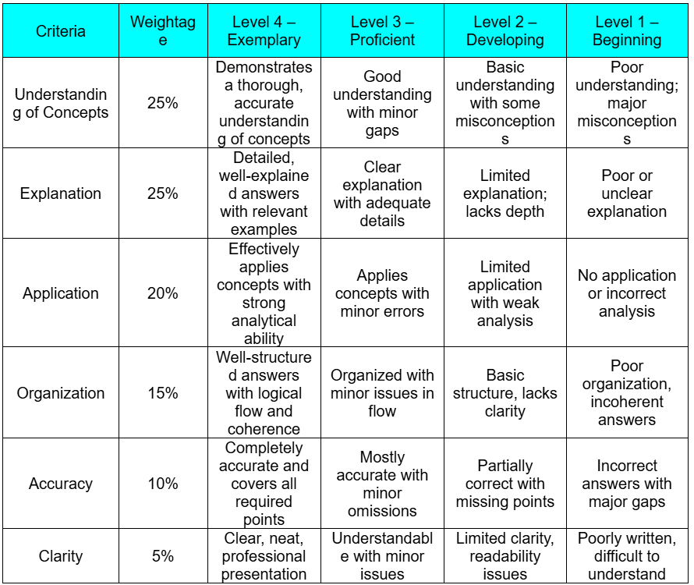
- Final transmitted data = 175.2 MB
RUBRICS FOR CALCULATION

